Try using Postman for API Testing:

RUN : #Python Final_api.py

Use Postman as shown below:

Create API Collection

And then using the POST method call the API.

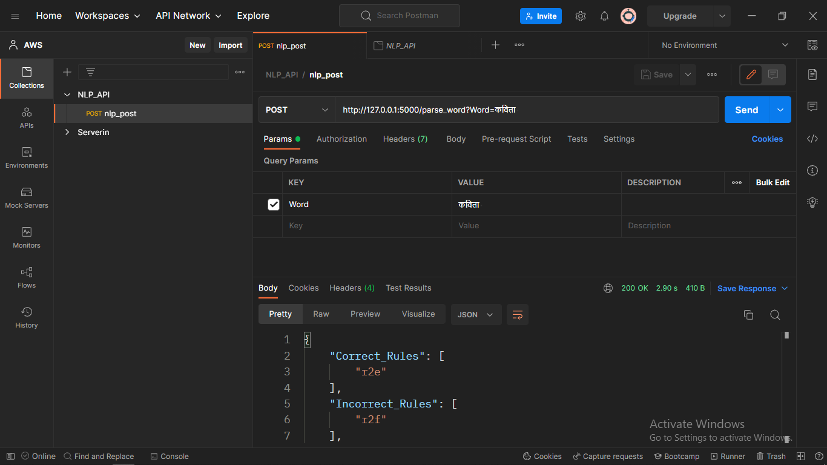

# TEXT_PARSER takes a string or a single word as a argument and replies in format {word : [[font_color], [suggestions]]}

# Word Parser Takes a post word in json format as {'Word' : "Query Word"} and replies json as {"Correct_rules" : [], "Incorrect_Rules" : [], "Spell": [[Font Color], [Suggestions if any]]}

# add_to_dict takes a json post as {"Add_Word" : Word to be added} and replies message if word added.

Predict Word : In this function we pass a json {"Word1": value, "Word2" : value} to the predicter and it responses as {"Suggestions" : [values]}

**URLs:**

**api.add_resource(Text_Parser, "/parse_text")**

**api.add_resource(Word_Parser, "/parse_word")**

**api.add_resource(Add_To_Dict, "/add_word")**

**api.add_resource(Predict_Word, "/predict_grams")**

**API URL :** [**http://127.0.0.1:5000/**](http://127.0.0.1:5000/)**<route_to_resource>**